Rose Murphy
7/2/23

Archival Data Collection

Comparing Beauty Standards from the Early Ages of Greek Goddesses to Modern Day
Planning notes:
Though social media has been the main factor in body dysmorphia in women, it also serves as a platform that exposes society to more diversity in body types, which includes the original beauty standard of Aphrodite (the goddess of beauty) - proving that beauty is not limited to one body type or beauty trend. I chose this method to physically visualize each body type per time period and see how they changed. By visualizing it, one can see for themselves and spur up questions like what caused it and why.
Methods:
Research a picture of popular women’s body types from time before the media (3 BC) to 2023. Years will include: 3 BC with Aphrodite, to the 1800s when photography was first being introduced, to the big years of beauty trends- 1950s, 1970s, 1980s, 1990s, to early 2000s- where social media was being introduced, to modern day with social media and the body positivity movement. Compare a picture from each time period and distinguish the differences and similarities between them. Factors include how the beauty trends of each time period affected what the popular body type of its time was.
The raw collected data
In the following photos, I Googled “women in *time period*”. These are the photos that came up:
3BC – Aphrodite, the goddess of beauty. The desired body type that was considered beautiful in 3BC was a curvier shape, has healthy fat and a natural tummy.
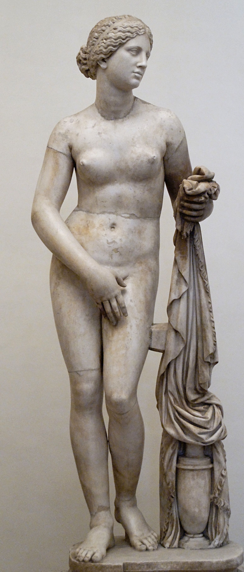
1800s – The age when photography was first introduced, the beginning of visual media. The woman in the beginning of photographs has big breasts, collarbone, chiseled face, bigger arms, bigger bottom, tiny waist, and a tummy.
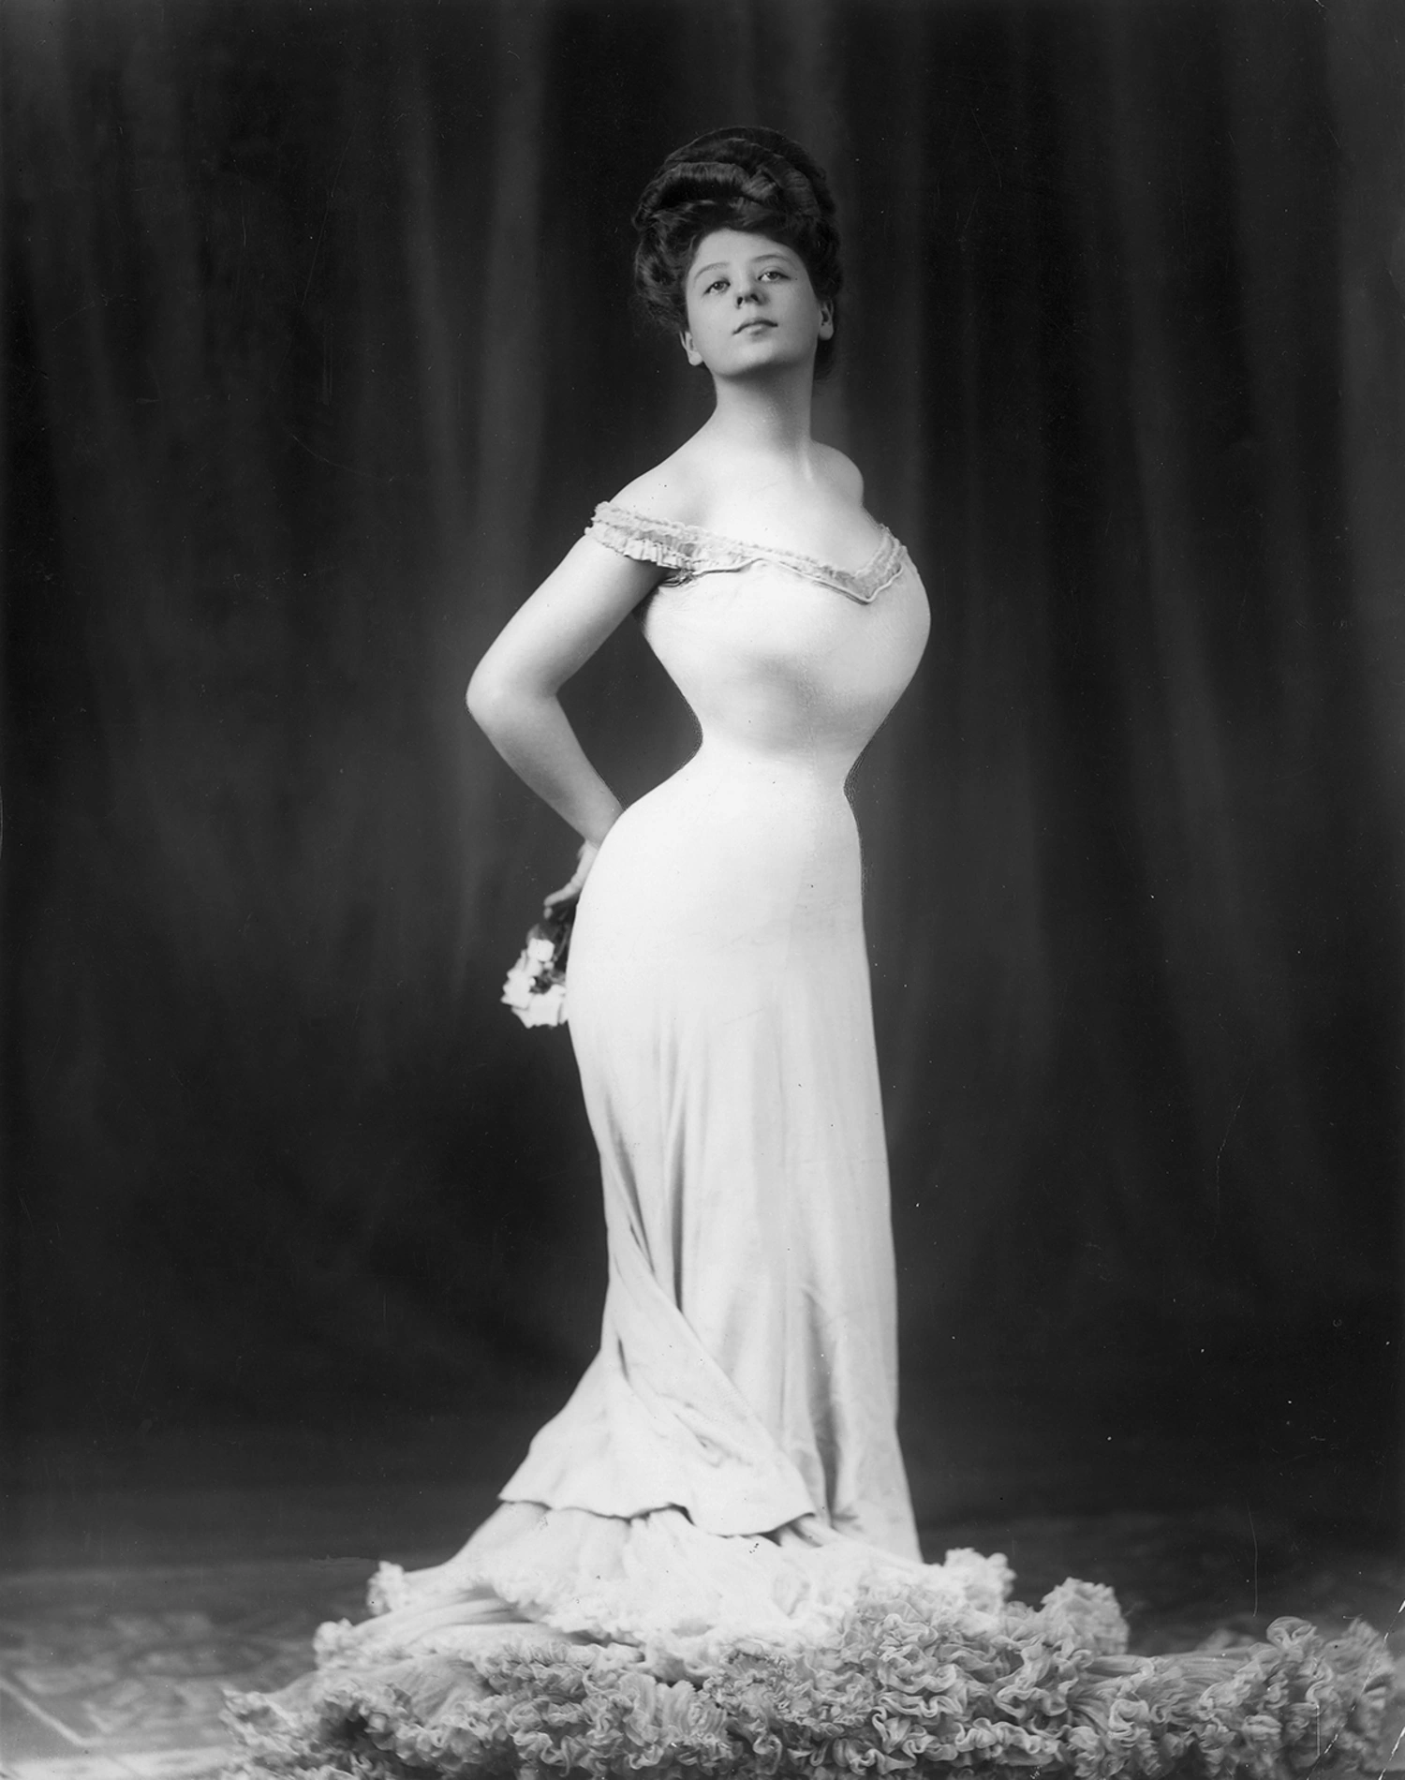
1950s – catalog women (the beauty trends) vs Marilyn Monroe (the exaggerated epitome of beauty and sex, though it was a natural body). The catalog women, who was the example of how women “should” look in the 1950s has tiny waist, little to no fat, smaller bottom, bigger breasts, little tummy. However, Marilyn Monroe, who was considered the most beautiful woman of that time, has a completely natural looking, normal body shape including a wider waist, but curvier figure with a bigger bottom, bigger breasts, fuller figure, little full tummy, more similar to Aphrodite's than the catalog woman.
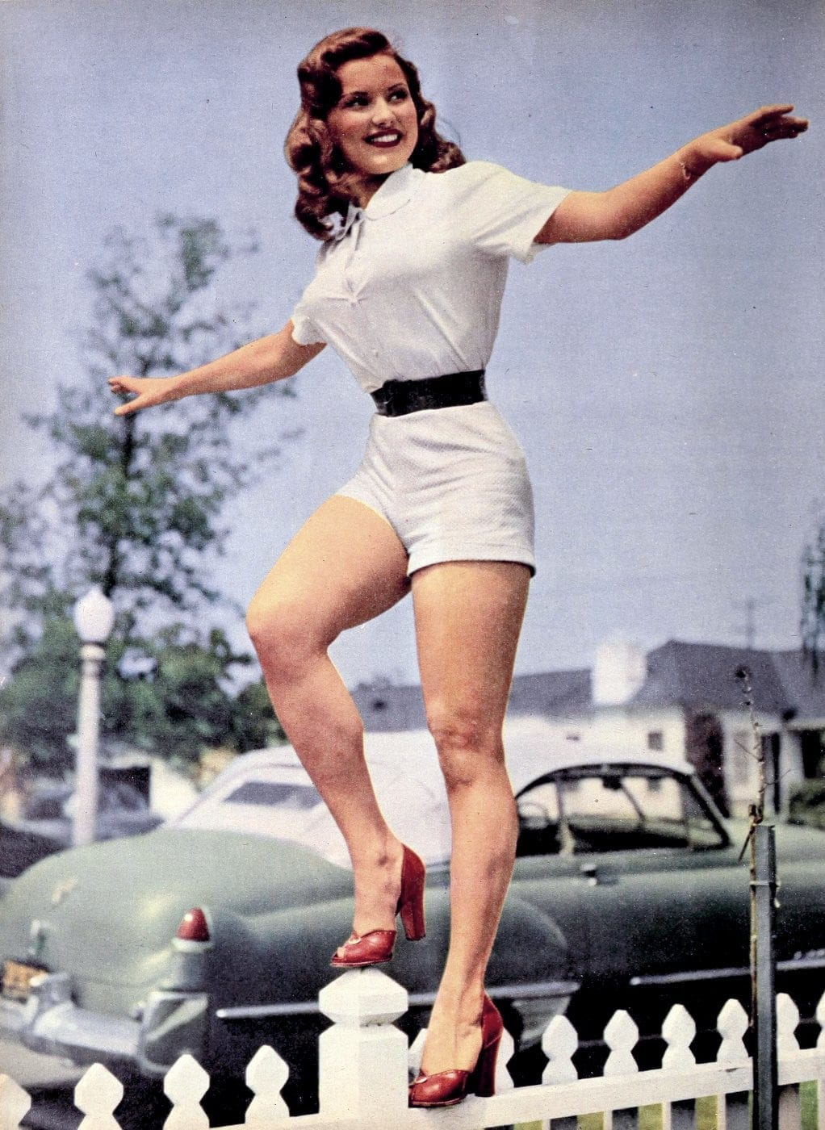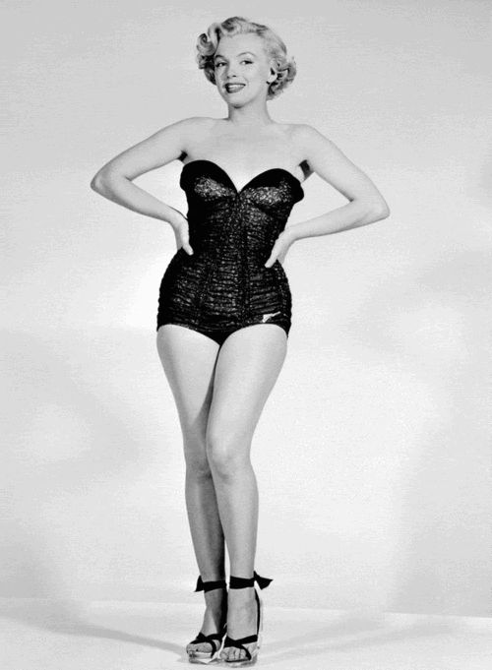
1970s – the age of disco and bellbottoms. Bodies that would fit in that style were considered beautiful: flat stomach, tiny waist, smaller breasts, chiseled body, taller, hips.
      - 
1980s – The age when exercise classes and having an athletic build was considered beautiful. Tall, smaller waist, toned, athletic, big hair, curvy but smaller bottom and smaller breasts.
      - 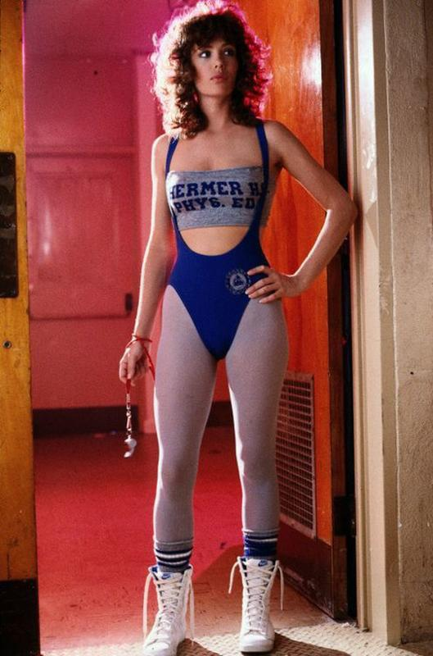
1990s – Jennifer Aniston, the celebrity crush of all time, was the definition of beauty in the 1990s. Every woman was getting her haircut and trying to follow whatever diet she was doing to look like her. Tiny figure, shorter, flat tummy, toned, dainty, messier demeanor.
      - 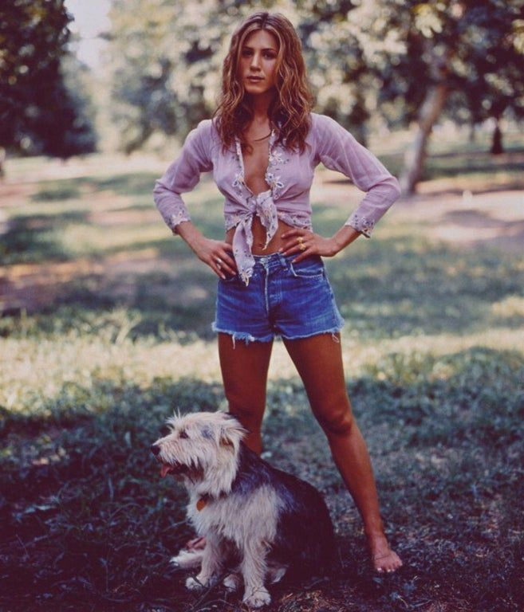
Early 2000s – The rise of low-rise pants and where stomachs were not in style. These pictures show 3 of the most famous women in beauty in the early 2000s: Sarah Jessica Parker, Paris Hilton and Rihanna. These photos proved that even women with different cultural backgrounds, with natural born different body types, are still considered more beautiful under the same body type. Flat to no tummy, low rise jeans, smaller hips, smaller (and exposed) breasts, little to no fat.
      - 

      - 

      - 
2023 - the body positivity movement and social media era. In the modern day, celebrities are much more accepting and prouder of the natural bodies they are born with and focus more on having a healthy lifestyle not to lose weight but to take care of their bodies. They are much more diverse and comfortable in natural bodies. The photo of Camilla Cabello is a popular photo of her being photographed at the beach. She is a curvier, more full-figured woman, where a decade before, she would be on every gossip magazine as “fat” and “unhealthy”. She took the opportunity with this photo to embrace body positivity and inspire women to love their bodies no matter how they look. And the bottom photo of the 3 women on the red-carpet show women of different cultures and body types embracing their beauties and being seen as gorgeous rather than need to be fixed to a specific type. While a decade ago, every woman on the red carpet would have the same body type.
      - 
      - 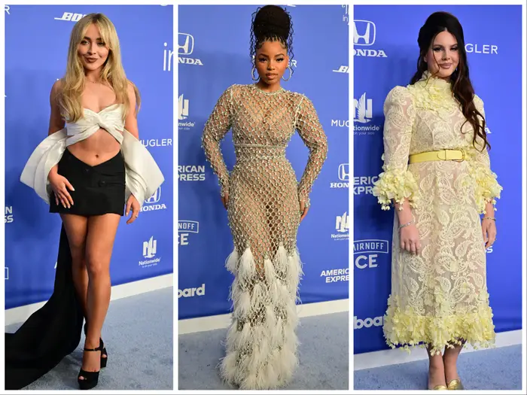

Ethical considerations
In terms of risks and benefits, it is beneficial to see how beauty in society has changed in time, though it also spurs up the risk that it can happen again. Though it is wonderful to see women embracing their natural bodies over time, this research also shows how fragile of a society we are and how easily changed and persuaded we can be to change to societies’ beauty standards.
Ethically, the more that the body positivity movement comes into light, I think social media has helped women appreciate their bodies than before- when women were only exposed to what they “should” look like, which was whatever body type was popular at that time. Even before the 1800s, when there was no media in the world, before there were cameras, there were still beauty trends and beauty standards, which causes self-comparison and leads to body dysmorphia. Because we do live in a world where media is very prevalent to society, being exposed to various body types and diversity in what different things women do to make themselves feel beautiful, the body positivity movement is the best way for women to feel encouraged to accept their natural bodies in modern day.
Future-directed reflection
What I realized when doing this research was how most of these women were considered “beautiful” and why every woman wanted to look like the woman of that era was because that was what men wanted at that time. Those beautiful women were the types of women who got the most attention from men at that time and is a big component on why women wanted to look like them so badly at that time. What worked well was having visuals to compare as true evidence and that the audience can see and decipher for themselves, rather than taking my word for it. What also worked well was having my background knowledge in the topic present and being passionate about doing this assignment.

